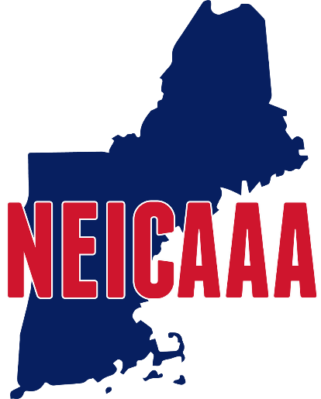

New England Intercollegiate Amateur Athletic Association

2023 NEICAAA Convention

As per the Constitution, a convention of the Association shall be held during the month of September. Voting will be done by the Athletics Director or his/her representative. All votes will be recorded.

Representatives must present to the presiding officer of the convention written authorization from their Athletics Director stating his/her right to represent such college/university in all matters before the convention

Format for authorization to vote required by Article VI, Section 3

_____________________is authorized to represent

_____________________College/University at the September 12, 2023 NEICAAA convention

Signature of Athletics Director_____________________________
Please bring to the convention or email it to neicaaa1887@gmail.com, so as to be received prior to the convention.

Shawn Green
145 Main St.
Durham, NH 03290

+++++++++++++++++++++++++++++++++++++++

